**SQL STATEMENTS**

**SQL STATEMENTS:**

1. DATA QUERY LANGUAGE
2. DATA DEFINITION LANGUAGE
3. DATA MANIPULATION LANGUAGE
4. TRANSACTION CONTROL LANGUAGE
5. DATA CONTROL LANGUAGE

**DATA QUERY LANGUAGE:**

1. SELECT

**DATA DEFINITION LANGUAGE:**

1. CREATE
2. ALTER
3. RENAME
4. TRUNCATE
5. DROP

**DATA MANIPULATION LANGUAGE:**

1. INSERT
2. UPDATE
3. DELETE

**TRANSACTION CONTROL LANGUAGE:**

1. COMMIT
2. ROLLBACK
3. SAVEPOINT

**DATA CONTROL LANGUAGE:**

1. GRANT
2. REVOKE

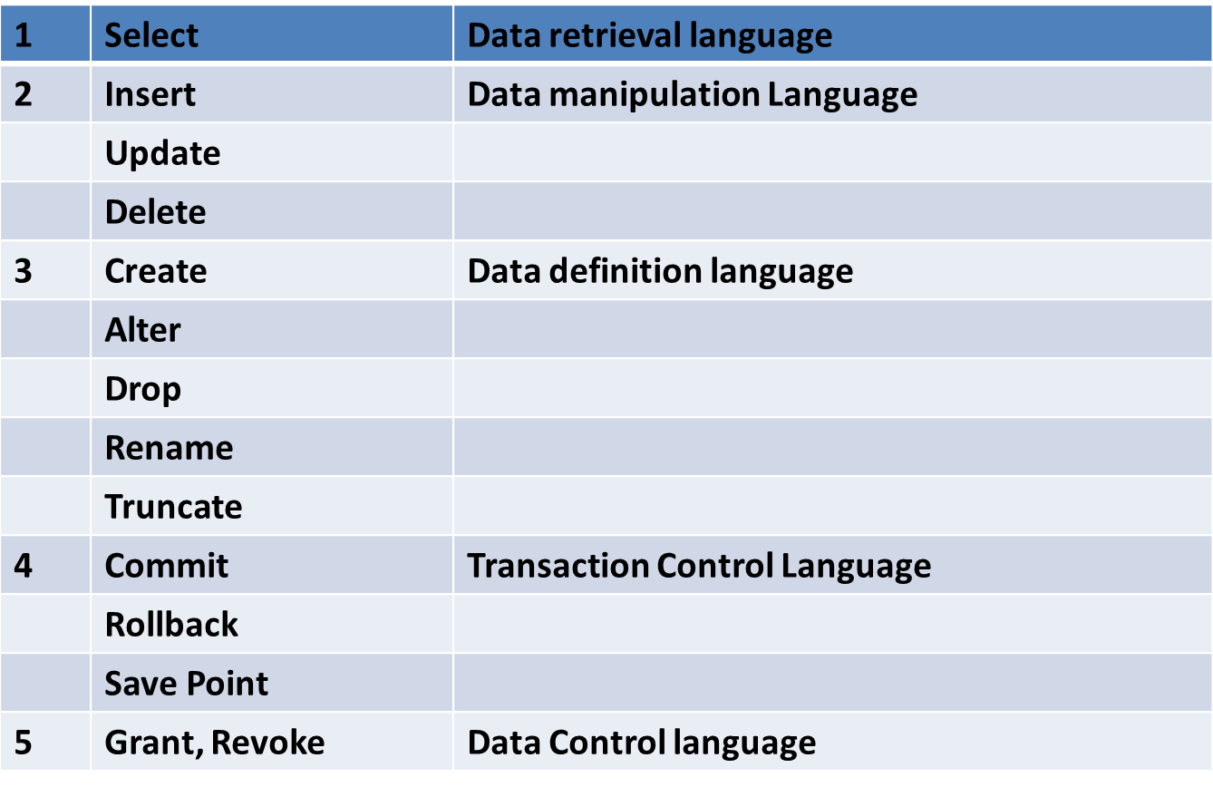

**SQL Statements**